

**SIT719 Security and Privacy Issues in Analytics**

**Pass Task 1.1: Understanding the Unit**

# Overview

### This unit will provide you with a unique learning experience that ties in two concurrent cyber-security disciplines, namely, data science and cyber-security. With the dramatic development of the Internet, Information Technology, and mobile devices, we are witnessing a great age of information. At the same time, security and privacy in cyberspace have become a critical problem for everyone, every company, and every nation.

### This unit provides you with learning experiences that explore the potential privacy and security of information and how analytics can be utilized to solve some of these challenges. Finally, you will study the ethical implications of dealing with large datasets and privacy associated analytics. All these topics will be explored through scaffolded programming assignments. Weekly assessment tasks will be submitted via OnTrack system. At the end of the unit, students will have a solid grounding in how modern analytics work and how they can be applied to network defence.

This is a Pass task, so you **MUST** complete the task and submit the evidence of your work to Ontrack.

**Instruction:**

This week task is simple where you start preparing yourself for the whole trimester. Please read the below comments and once you are ok with everything mentioned in this document, **submit the PDF using OnTrack**. **A word version is added in the resource file in OnTrack.**

# Section 1

### Write the answer to the following queries:

### Q1. What are the Unit Learning Outcomes (ULOs)? Hint: you may find at the first-week class slides or look at the unit guide.

Answer1:

**1.UL01** Scripting skills as they relate to large datasets that are encountered in cybersecurity, and the use of popular toolkits used to build analytics.

**2**. **UL02** Recognise and apply the relevant ethical, regulatory and governance constraints on organisations and professionals when dealing with data and analytics.

**3.** **UL03** Understanding the basics of supervised and unsupervised machine learning algorithms, including their basic mathematical underpinnings, and how they can be implemented using popular libraries.

**4.** **UL04** Understand how analytics can be used to protect computer networks as well as what types of network defence data might be useful for building analytics. Explore what types of attacks have been successful mitigated by the current state of the art and where work still needs to be done.

**5.** **UL05** Understand the technical threats to privacy that may result from the use of analytics in cyber security.

### Q2. Have you received the Github link?

Answer: ………**YES**………… (yes or ~~no~~)

If no, then look at the news item of CloudDeakin for the link. You will get the link there. Typically we post the major updates in the news item of CloudDeakin.

### Q3. Have you successfully installed Anaconda/jupyter notebook **OR** imported everything from Github to Google Colab?

Answer: ………**YES**………… (yes or ~~no~~)

If no, then look at the week 1 Workshop video. If still confused, consult the tutor during the workshop sessions.

Now, please practice prac_01 task that you received from github link (first practical). No further action needed. Thanks.

### Q4. Please write briefly about the concept of portfolio-based unit. (If not sure follow the first-week class lecture)

Answer:

The concept of portfolio-based unit is to work through number of tasks assigned each week with the help of online web application **On track.** On track support students to complete learning and assessment activities on time and to achieve the target grade and unit learning outcomes. At last all the successfully completed tasks are combined together with students own understanding on the learning portfolio for the final assessment.

### **Section 2**

### **Q5.** Read the following comments.

### **Comment 1: OnTrack Issue**

### This unit uses onTrack system. Therefore, you need to submit tasks using OnTrack (if not mentioned something else within the tasks, e.g, code may need to be submitted using CloudDeakin, it will be written in the task document clearly if so). You need to upload PDF document files during a regular submission using OnTrack. Please ensure that the PDF has no error or corrupted. If you find an OnTrack error, report it in the OnTrack Issues.docx” file under the file tab of MS Teams. YOU DO NOT NEED TO SEND EMAILS. We will try to resolve if that is a genuine case and related to OnTarck Platform. We recommend reporting in that file so that it will be recorded for everyone. If it is because of your own pdf compilation, your internet, software or laptop issue, we will not be able to help you.

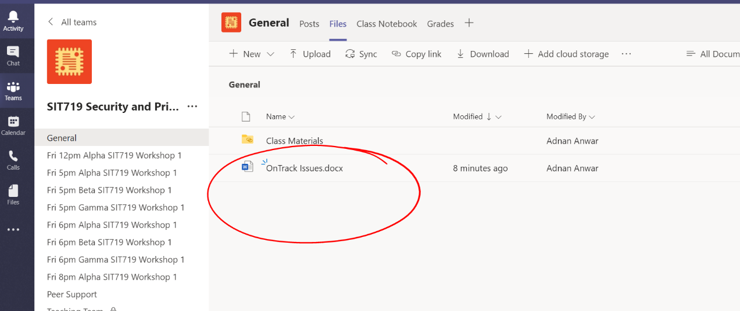

**Comment 2: Task discussion**

Any question or concern should be discussed during the online “workshop/practical lab” sessions. It is the recommended way. If you cannot join, you may ask the tutor through your onTrack discussion box (shown below) or post into your MS Teams channel rather than sending individual queries. I have created a peer-support group within MS Teams. It may happen that the answer of your question is known to your peers. You are suggested to join the seminars and/workshops to clarify your queries. Alternatively, you can use “Discussion forum” in CloudDeakin to share your thoughts or questions.

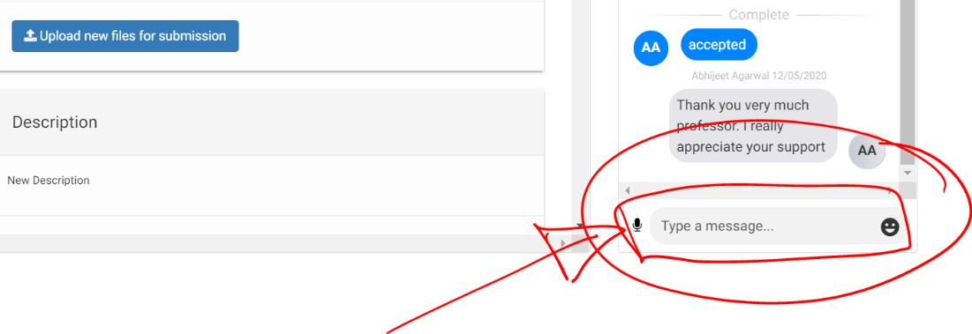

**Comment 3: Extension Request**

We have already set the deadlines and students are aware of the due date of the tasks beforehand. Therefore, for any contingency or future events, students can plan ahead. However, if things go unexpectedly and you need an extension, I will allow up to 2 weeks of extension (also includes covid and related situations). In those cases (illness or covid or unexpected events), you need to add a “rationale” (any format) and/or “medical certificate (if any) at the end of the onTrack tasks. Please note, **there is NO NEED TO SEND EMAILS to the Unit Chair or APPLY for EXTENSION**. The **tutors/markers will automatically accept when they find that information at the end of the task submission**. If you need to apply for more than 2 weeks of extension, then you need to be very detailed and clear about your supporting documents and need to follow Deakin’s guideline (in the below link). If you request for an extension over 2 weeks and your request is not approved, you may not be allowed to submit that task.

<https://www.deakin.edu.au/students/faculties/sebe/assignment-extensions>

**Comment 4: Grading/Marking**

The tutors/markers are responsible to provide you feedback and grades on your tasks. The teaching team performs it very professionally. Simple pass tasks are not graded (must pass the units). The C and D/HD tasks will carry grades/marks (and based on your marks, your final grade will be decided). The tutors/markers do it in a very professional way with sincerity and care. D/HD tasks have a rubric. The marking team will provide you feedback based on the rubric. The aim is to make a proper judgment based on the quality of your submission. As the markers will scrutinize and review the reports from a large number of students, they will try to make a fair comparison among the students and make a proper judgement on your learning outcomes. If you are not satisfied with your marking, you need to communicate with the tutor/marker through OnTrack discussion box. So, as unit chair, I will suggest you to put trust in the teaching/marking team and my experience shows that the teaching team always cares and tries to make proper evaluation and judgment for the students.

**Comment 5: Practical Notebook file error**

We have provided you with notebook files for practicals/workshops. Those files have been tested, reviewed and checked carefully. If there is still any bug/error, please report it to the “notebook bug.docx” file of the MS Teams under the file tab. There is no need to send emails. We will check and respond. If it is due to your own configuration issue, we may not provide support.

**Comment 6: Recordings for online class (seminars) and workshops (practicals)**

The online class and practicals will be recorded. Please allow 2 business-days to upload the file into CloudDeakin site. Please see the recordings within “Video Recordings for Classes and Workshops” folder under the “content” tab.

**Comment 7: Please keep a back up copy of your onTrack tasks**

Please keep a back up copy of your onTrack tasks as long as you are a student at deakin.

**Comment 8: Referencing Style**

Any **standard referencing style is accepted**. However, IEEE style is preferable..<https://guides.lib.monash.edu/citing-referencing/ieee>

**Comment 9: Update “Target Grade” in the OnTrack System**

In this portfolio unit, you must set a “target grade” (discussed in the class, see the video if you have missed). To set up a target, you must consider your capability and your plan towards achieving the ULOs. Please set a realistic target that you can achieve. This target is for your reference only and you can change/modify the target anytime. The teaching team will evaluate your tasks based on the quality of the submission and your relative performance compared to the group irrespective of your pre-set “target grade”.

**Comment 10: Learning Material**

This is a portfolio based unit where students learn gradually over the weeks and finally submit a portfolio by compiling the tasks that they complete each week. Therefore, learning is completely based on OnTrack tasks. The teaching staff try to relate the weekly class and workshop activities related to those tasks

**Question:** Are you okay with the above discussion/comments in Q5?

Answer:

A. “Yes, I am okay with this arrangement” – if you are okay please submit the task as “Ready for feedback”

B. “No, need a discussion” – If you need clarity, please start consulting your tutor/unit chair and when you agree, please submit the task.